Step 1: Download the CrowdBlink Protect app on your phone.
You can find the app by searching for "CrowdBlink Protect" in either the Apple App Store or Google Play Store.
Alternatively, simply follow these links:
iOS / Apple:
Android:
Note: The app for employees and self-assessment is only available through a mobile device. You will not be able to sign up for the app through the web portal.

Step 2: Open up the app and create an account.
Before you can start doing self-assessments, you will need to create an account. All you need to do this is an email address. Here's how:
- In the app, click "Sign Up" at the bottom of the screen.
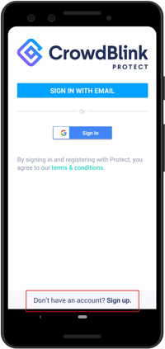
- Then, enter your email address, create a password, and sign up.
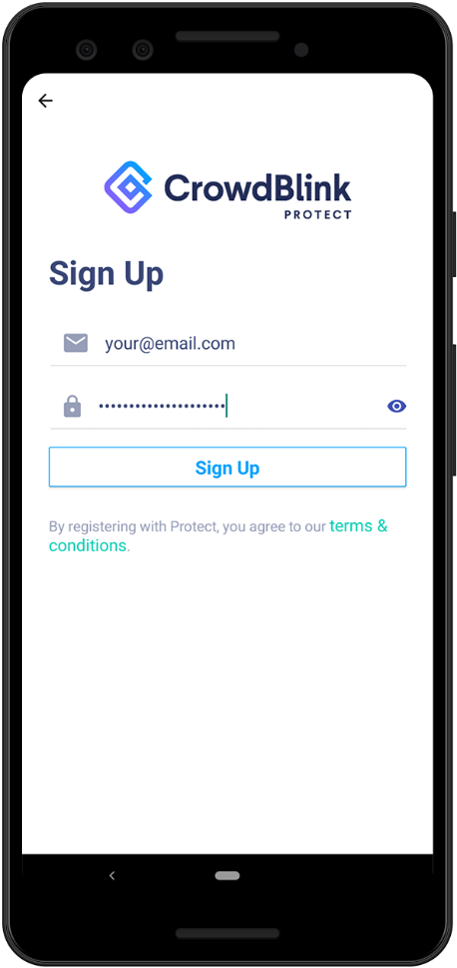

Step 3: Confirm your email address.
After you sign up in the app, CrowdBlink sends you an email with a unique link. Use it to confirm your account.
- Upon signing up, you are asked to authenticate.
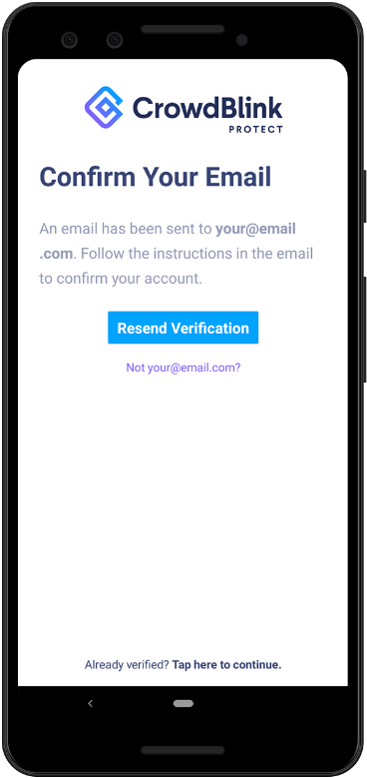
- Open up your email inbox, find the email from CrowdBlink, and click the unique link to verify your email address.
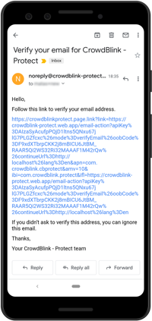
Once you have verified your email address, you are ready to use the app!

Step 4: Enter your organization's location code and finish set up.
Open up the CrowdBlink Protect mobile application again. You will now be able to log in using the account you just created with your email address and password.
Once you log in, you will be taken to the authorization screen, where you will need to enter your organization's 6-letter Location Code. If you do not know your unique location code, check with the company's manager or administrator.
You only need to do this step once. After you enter your organization's location code, it will be saved to your profile, unless your administrator removes you from the location. Here's what that looks like:
- Enter your organization's unique Location Code (6 letters). Our organization code is TPQNIH
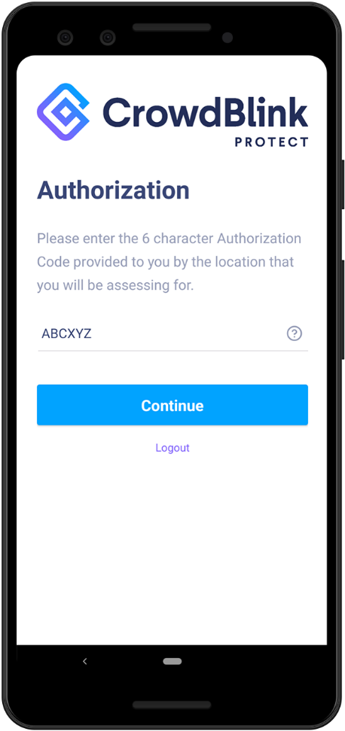
- On the next screen, enter your name to finish setting up your account.
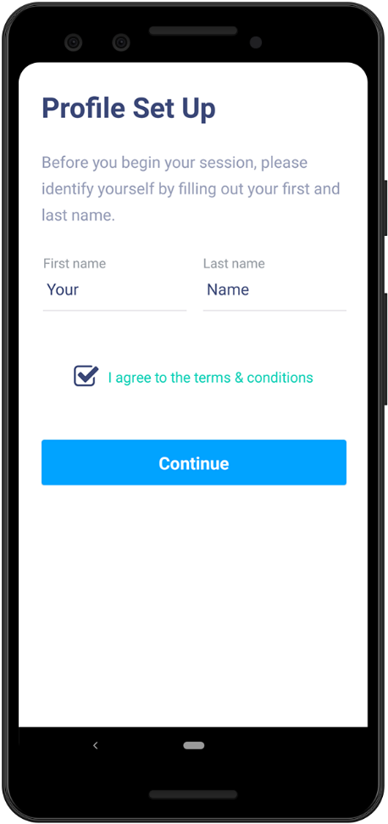

Step 5: Start conducting daily assessments.
That's it — you are now ready to do daily self-assessments. All you have to do now is open up the app and follow the steps. That means:
- If you see a yellow bar around a QR code with a status message SCREENING REQUIRED, that means you need to follow the screening steps before going to your work location. Click START.
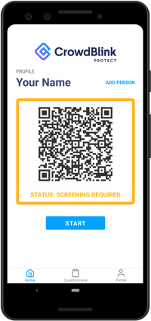
- Next, you will be taken through a set of steps and questions. Please answer all of them and submit your answers.
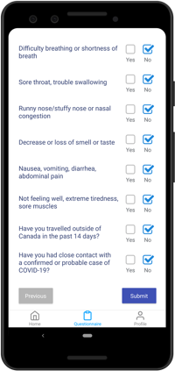
- After you have submitted your answers, if your QR code bar turns green and the status reads SCREENING SUCCESS, you may proceed to your work location. If you have failed the Covid-19 screening, please follow the protocol as instructed by your employer or organization.
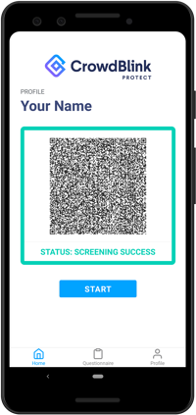
This assessment will stay valid for a set amount of time (determined by each organization).
When you open up the app again after the validity period has passed (for example: the next day), the QR code will turn back to yellow. This means that you are required to click START again and do the assessment again before entering your workplace. This ensures that everyone in the organization is conducting self-assessments before going to the work location.

How to use the QR Code (only if you are required to scan in).
Depending on how your employer or organization is using CrowdBlink Protect, you may need to use the green QR code to scan in at your work location before entering.
If you are required to scan in, your employer will either have a tablet stationed at your work location, or have somebody scanning people as they arrive.
If you are using a tablet to scan in yourself:
- Click the SCAN button on the tablet (Note: you do not need to click anything on your own phone this time — simply open up the app).
- Show the QR code to the tablet's camera. This will scan your QR Code and completed assessment.
- Click Next at the bottom, complete any additional steps if required, and submit your assessment on the tablet.
- That's it, you've now scanned in and may enter.

